Coaches/Admins Score Games
Winning Teams will need to score your games in Affinity Sports ShareView™ System click on the link below. Home Teams will do in cases of Ties.
Coming Soon
In the upper left corner of your screen log in using your same credentials you use for Risk Management/Background Check. If you do not know your credentials please click on Forgot Password to attempt to connect to your account. Your email address must be current in our system for this feature to work. If you do not receive an automated email within 5 minutes click on the Tech Support Contact link on the left Navigation and call Affinity Sports or open a help ticket. Call 1.855.980.2886
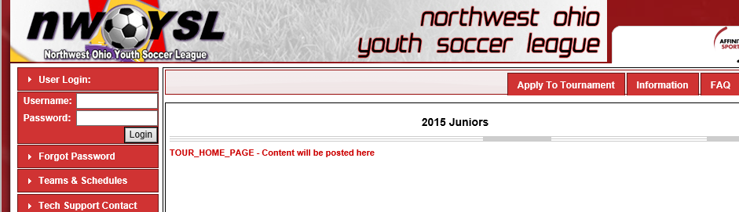

Once you have signed in make sure you are on the “My Account” tab in the upper right corner.

Scroll down the screen to where you see the header “Tournament Applications / Game Scoring.
Click on Schedules / Game Scoring on the right side of your screen.
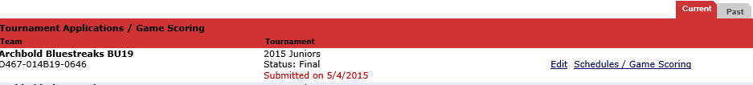

To enter the score for a game you played please click on the empty Score box next to your team name.

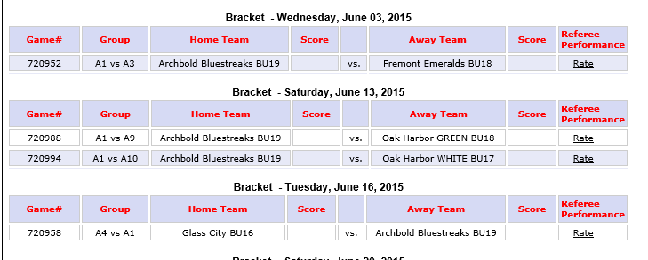
You will enter the score as well as any other required game stats on the pop-up screen as seen below.
You may enter stats for goals scored as well at this time.
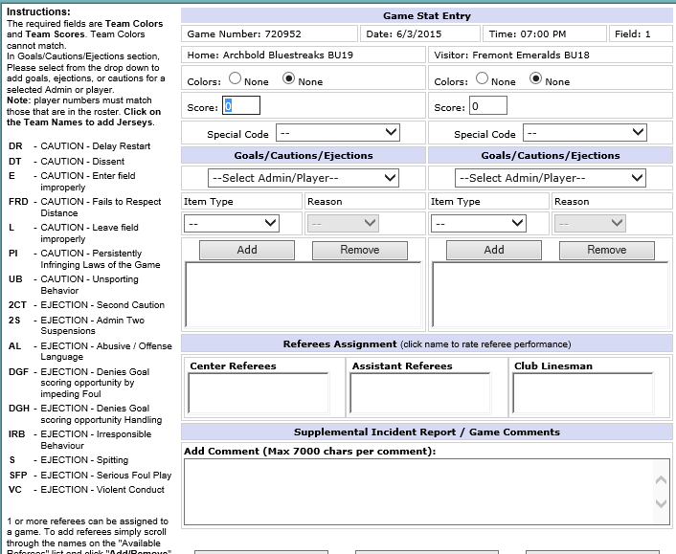

Once you have entered your scores and stats click Save Stats & Comment.
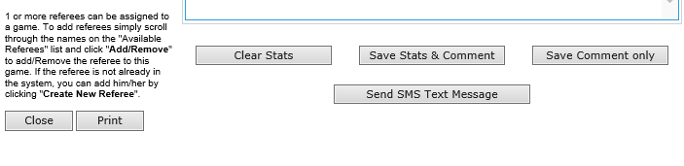
Winning teams are asked to update the scores with in a 48 hour window of the game. In cases of a Tie; the Home team will enter the score and turn in the game day reports.

